Observation checklist for a PowerPoint enhanced learning session
Name of facilitator |  | Date

Assessor

COMPETENCE AREA 1 | The hardware is competently used / handled
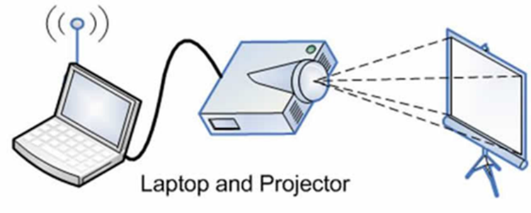
Criteria |  | Comment
Screen, computer and projector have been properly positioned considering:
- Size room
- Seating arrangement
- Power supply point
- Sunlight through windows not to ‘hit’ screen
No trailing cables in places where learners / facilitator move
Projector is properly focused
System has been correctly set up by the teacher/trainer
- connecting cables correctly placed
- focussing of beamer
- screen image appropriate in size and shape
- laptop/computer set at presenters view (full view to screen, ‘speakers note view’ on laptop)
Screen image is not distorted (no blue fringing or keystone effect)
Facilitator does not walk in front of the image / block the image from view
Facilitator does NOT point to screen with stick / hand but uses instead
Facilitator shows slides at the right time

Facilitator makes appropriate use of animation feature
- Text / images on slide appear (or are highlighted) at the appropriate time
Facilitator moves to the next slide at the right time

Facilitator uses “B” “W” keys to gain attention / switch off PPP as soon as the image is not needed, avoiding distraction
Facilitator uses sound effectively (if applicable)

Facilitator uses video effectively (if applicable)

Facilitator makes appropriate use of laser / pen / highlighter to emphasize aspects on the slide when presented (Ctrl L, Ctrl P, Ctrl H ; or uses the icons on the screen)
Facilitator competently uses remote control (if applicable)

COMPETENCE AREA 2 | The resource is relevant and promotes a learner centred approach
Criteria |  | Comment
Relevant to coverage of LO/PC(s) and range statement(s)
Essential (Learning required could not have been effectively conveyed without the use of the learning resource)
Suitable for all learners considering their
- Age
- Vocational area
- Level of education
- Cultural background
Improving learners’ understanding / consolidating learning

Activity based (learners actively interact with the resource)
Encouraging high level of learners involvement

Motivating to learners / attracting attention / stimulating learning
Holding attention of learners

Factually correct-topic covered thoroughly

Artistically correct (lay out, font size, use of colour, use of images, use of sound, use of animation / minimising effects to essentials)
Using appropriate language (level, non-discriminatory / non offensive)
Containing / presenting up-to-date, current information

Tailored to time available
- Minimised number of slides
- Each slide is essential
Not violating copy right laws / resources used are acknowledged

COMPETENCE AREA 3 | The facilitator uses the PowerPoint slides in a competent way during the learning session.
Criteria |  | Comment
Interactive use of the slides
- Does not read from slides / notes
- Faces learners / monitors learners / addresses learners
- Ensures participation of all leaners
- Uses techniques to enhance learners’ interaction with the slides (including interactive textboxes)
- Regularly checks learners’ understanding
No disturbing mannerism / annoying movements
- Playing with hair
- Looking down, not at audience
- “Fumbling with change in pocket”
- Rustling and shuffling notes
- Popping the top of a pen
- Too many ‘ahh’,’um’, ‘okay’ etc (fillers)
Body language is supportive to enhance learners’ participation
- Position
- Posture
- Gestures
- Appearance
Use of eyes
- sweeps reasonable slowly round the audience,
- makes eye contact from time to time with different individuals just for a moment,
- avoid eye contact with the same people
Appropriate use of voice
- Clear
- Audible throughout the room
- Well-paced / pausing
- Change in volume, pitch
- Radiates enthusiasm
Appropriate use of the PP slides to enhance learning
- Number of slides is well timed for time available / no rushing
- Gives sufficient time to learners to read / view the image
- If learners are on a task screen in blank or off
Appropriate handling of questions
- Encourages questions throughout
- Ensures question heard by audience
- Invites responses from other learners
- Ensures concise response
- Demonstrates tolerance for different ideas, belief systems
- Acknowledges if do not know the answer (“I don’t know. I will find out for you”)

Guidance to assessor
This is a competence based course i.e. ALL listed criteria have to be achieved. Hence in the comment section you write the evidence observed meeting the criteria. It is NOT a tick list!
If candidate is NOT competent on some criteria REASSESSMENT on those areas only has to be arranged. You are not helping the candidate, nor the quality of TVET when declaring a candidate competent while there are still areas of incompetence. Candidate should be proud to know that they are competent, there is no pride in being declared competent and knowing very well that certain criteria were NOT achieved. There is no shame in needing reassessment – it is part of the learning process. If reassessment is needed make arrangements and attend only to the criteria NOT achieved. Use same observation form above for reassessment as only not achieved criteria require attention and comments. The comment box could read: Not achieved during first assessment. On 2nd assessment observed <write what was seen> and hence declared competent on this criteria.

Assessor’s decision

1st Assessment session

Overall Comments:

Decision COMPETENT ☐
NOT YET COMPETENT ☐
The follow criteria need attention in the reassessment:

Signature of Assessor: _______________________________ Date: ________________

1st Reassessment session

Overall Comments:

Decision COMPETENT ☐
NOT YET COMPETENT ☐
The follow criteria need attention in the 2nd reassessment:

Signature of Assessor: _______________________________ Date: ________________

