Example – checklist for partly completed PowerPoint slide set
What I have to cover in my set of slides to demonstrate my skills in using MS PowerPoint features.

Creating slides
I can | √ | Evidence
Start a new presentation | ☒ | Evidenced by submitted self-designed PP slides
Choose slide layouts | ☒ | Slide 1 & 2 Title slide layout; slide 3 & 4 Text and content layout
Enter text | ☒ | Slide 1, 2, 3, and 4 and others
Insert new slides | ☒ | e.g. slide 1 and 3 and others
Duplicate slides | ☒ | Slide 2 duplicate from 1 with modified theme
Insert blank slide | ☒ | Slide 5, 6 and 7
Add presenter notes | ☒ | All slide notes on features demonstrated in slide
Save presentation as a .ppt / .pttx file | ☒ | Saved as pttx (2013 MS PowerPoint)
Present slides in a word document | ☒ | This document, see last part
Formatting slides
I can | √ | Evidence
Select a theme | ☒ | Slide 1 Theme executive; slide 2 theme Trek
Modify a theme | ☒ | Modified theme from slide 1 to slide 2
Choose different slide layout | ☒ | Slide 1,2 are title layout; 3.4 are using text and content; slide 10 title and two contents
Create bulleted or numbered list | ☒ | Slide 7 list; slide 2 demonstrates different type of bullet
Format text:  - size,  - font type  - colour,  - alignment: | ☒ | Variety in text size, font type and colour shown in slide 1, 2, etc. see in notes under the slides. Slide 1 font Calibri, size 26; slide 2 font Old English, size 32. Alignment slide 4, slide 6 (text boxes aligned). Slide 8 aligned text boxes with the Roman numerals
Insert and format graphics
I can | √ | Evidence
Insert a picture | ☒ | Slide 5, 6 ,8 and 10
Move a picture | ☒ | Slide 6, 8
Adjust colour, brightness and contrast to a picture | ☒ | Slide 8 brightness / contrast changed in II from I; colour changed in III from original in slide 6
Resize a picture | ☒ | Slide 6 resized picture 1 to picture 3; Slide 8: resided picture 2 from slide 6
Crop a picture | ☒ | Slide 6 copied picture 1 and cropped to picture 2
Insert a shape | ☒ | Slide 9 basic shape (face) and call out
Format shapes | ☒ | Slide 9 resized shapes, filled face with colourt, adjusted call out, inserted text box for text in the call out
Insert a symbol, special character | ☒ | Slide 7
Insert WordArt | ☒ | Slide 2
Modify WordArt objects | ☒ | Slide 2: fill, text effect: transform
Insert a SmartArt | ☒ | Slide 4
Modify SmartArt (move, resize) | ☒ | Slide 4 : segmented process colourful range
Insert a chart | ☐ | Click here to enter text.
Modify a chart (move, resize, colour) | ☐ | Click here to enter text.
Insert a text box | ☒ | Slide 5, 6, 7 and others
Create a table | ☐ | Click here to enter text.
Format tables | ☐ | Click here to enter text.
Insert slide number in footer | ☒ | Slide 1
Align objects | ☒ | Text boxes aligned in slide 6 and 8
Insert a video clip | ☒ | Slide 9 hyperlink to video clip
Animation
I can | √ | Evidence
Add slide transitions | ☒ | On click, 1 to 2, push 2 to 3; random bars 5 to 6
Apply animations to objects | ☒ | Slide 2 swivel, automatic time 1.75 sec; slide 3 fly in. bouncer, split+emphasis: wave
Create an interactive textbox | ☒ | Slide 5
Add hyperlinks | ☒ | Slide 3 hyperlink to slide; slide 9 to a video clip

My set of PowerPoint slides presented as a word document as shown here below.

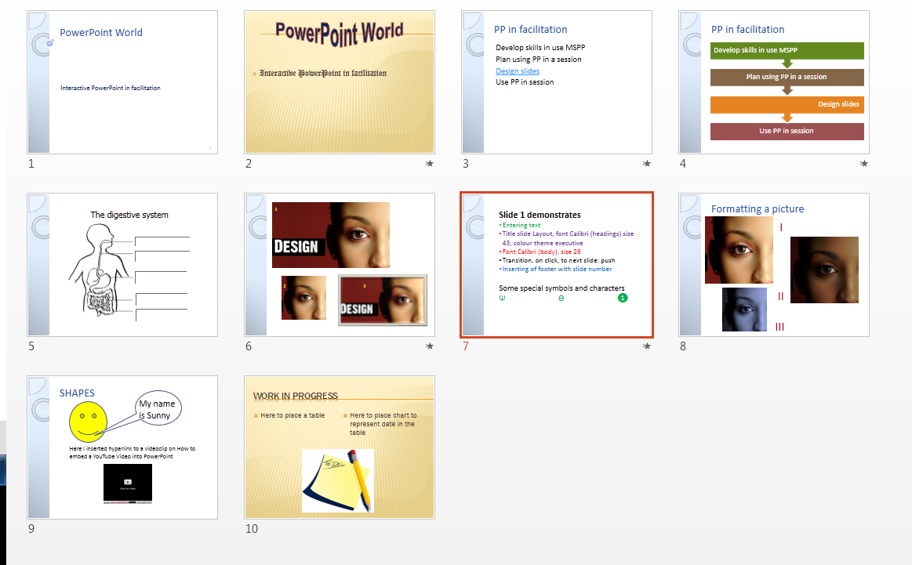

e.g. screen shot of slide sorter view, or picture of the individual slides, 6 or 8 per page. Use insert option in MSWord choose screenshot option.

