Navigations
There are two ways you can navigate around Moodle:
  - using the Navigation block
  - using breadcrumbs

1 Using the navigation block
The navigation block is located on the left side of the screen. This area contains pods that allow you to access:
1. Site pages
2. Your courses
3. Your profile
4. Your profile settings
5. Site administration

“Docked” blocks

The following image is an example of a navigation pod by clicking the docked administration block

Clicking on these links, or on the arrow next to them, will open sub-menus that enable you to access more areas of the site.

2 Using breadcrumbs
Breadcrumbs are links provided at the top of the page, and at the bottom when viewing one topic, which show the hierarchy of the site. These are particularly useful when navigating within a site to previous or next topics.
Below a screen shot when topic 1 is active

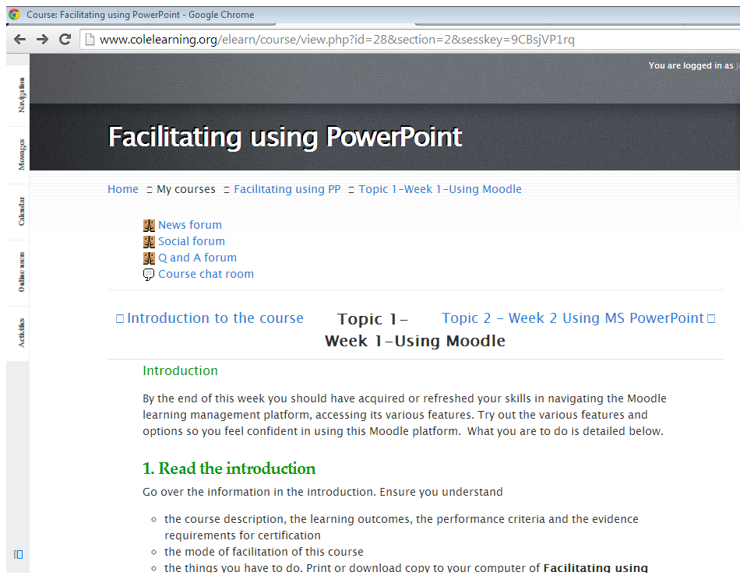
Breadcrumbs lines

