How to Guide: Creating a Login on the C-DELTA platform.

Go to the website https://cdelta.col.org/. Click Sign up

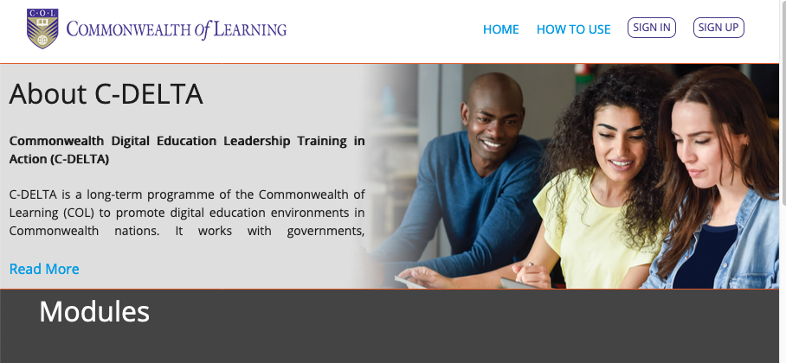

This takes you to a page where you need to enter personal details.

Enter you Name and Gender. Enter your email.
Select your User type (Choose Teacher/ Practitioner).
Don’t enter anything under University Enrollment Nymber
Indicate if. You are joining as an individual or part of an organisation, institution or group

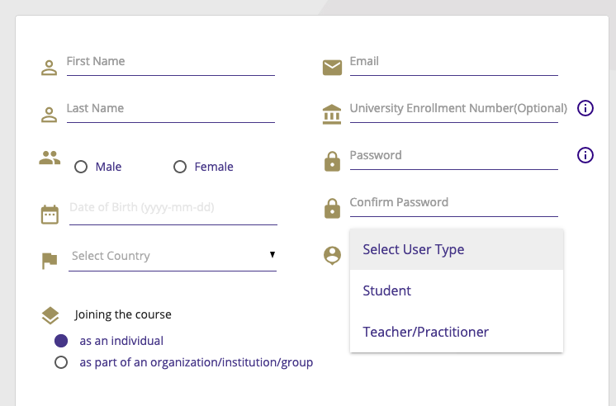

Choose a password. It must contain at least one number, one uppercase, one lowercase letter, one special character and at least 8 or more characters.

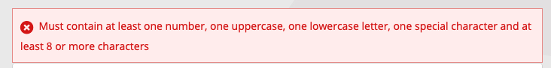

Select your date of birth. When you click on this a box will pop up so you need to choose the day, month and year.
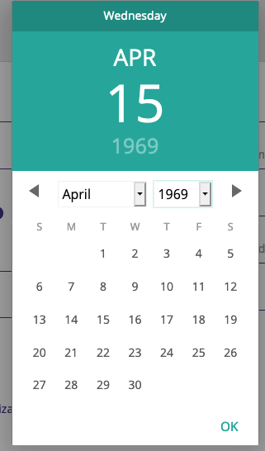

Select your country from the Drop Down box.

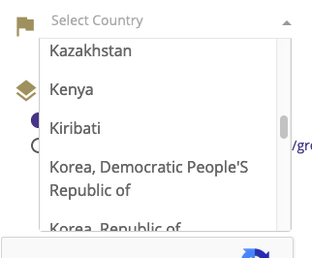

Check the “I’m not a robot box and then select the Register button at the bottom of the screen to agree to the terms and conditions.

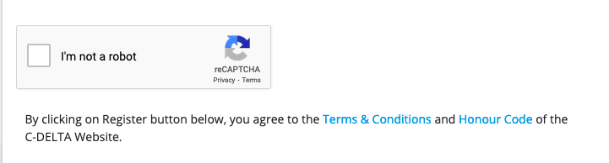

Once you click register successfully you will see a message indicating your need to check your email

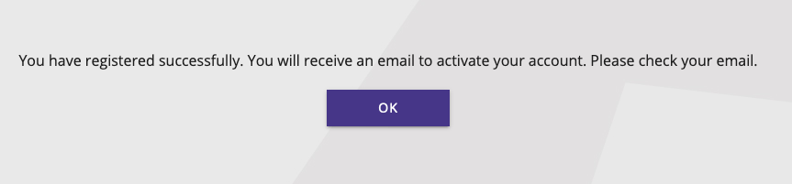

The email will come from c-delta-noreply

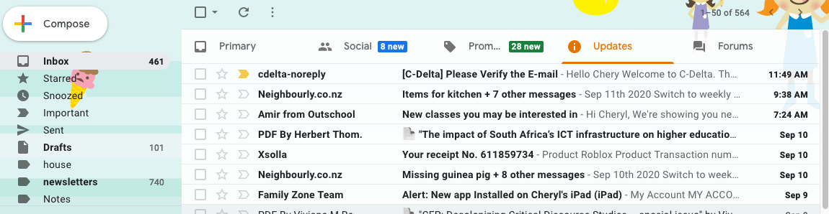

If you don’t see it in your Inbox or updates folder (if you use gmail) check your Spam or trash folder.
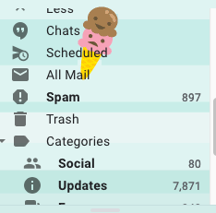

The email will ask you to click a link to verify your email.
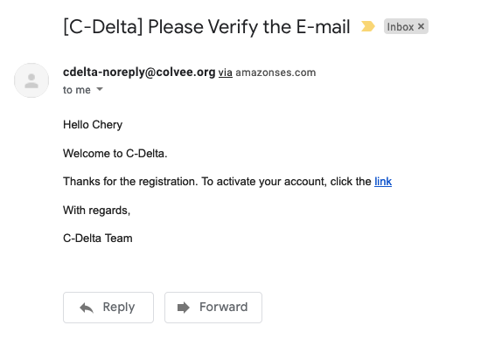
When you click the link your account will be activated and you can now login to C-DELTA.

